Benin

## Political Stability Estimate Data

The data set shows the political stability estimate of the country each year.

## # A tibble: 19 x 5  
## country iso3c date stability stabilityCategory4   
## <chr> <chr> <dbl> <dbl> <chr>   
## 1 Benin BEN 1996 1.05 highly stable   
## 2 Benin BEN 1998 0.741 moderately stable   
## 3 Benin BEN 2000 0.798 moderately stable   
## 4 Benin BEN 2002 0.820 moderately stable   
## 5 Benin BEN 2003 0.679 moderately stable   
## 6 Benin BEN 2004 0.265 moderately stable   
## 7 Benin BEN 2005 0.447 moderately stable   
## 8 Benin BEN 2006 0.547 moderately stable   
## 9 Benin BEN 2007 0.386 moderately stable   
## 10 Benin BEN 2008 0.375 moderately stable   
## 11 Benin BEN 2009 0.403 moderately stable   
## 12 Benin BEN 2010 0.261 moderately stable   
## 13 Benin BEN 2011 0.318 moderately stable   
## 14 Benin BEN 2012 0.364 moderately stable   
## 15 Benin BEN 2013 0.301 moderately stable   
## 16 Benin BEN 2014 0.0271 moderately stable   
## 17 Benin BEN 2015 -0.0135 moderately unstable  
## 18 Benin BEN 2016 -0.00203 moderately unstable  
## 19 Benin BEN 2017 0.0453 moderately stable

## Political Stability Estimate Plot

The plot shows the trends of stabilization and destabilization for the each country.

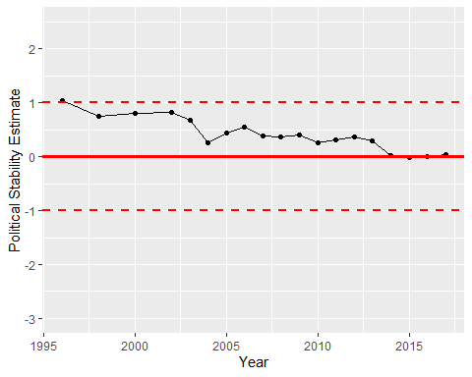

Political Stability Trend